1. Log into [www.FamilyID.com](http://www.familyid.com/) . You will be asked to put in an email & password.
2. Switch to your personal account. It will be your last name plus “Family Account”. For example, Nguyen Family Account.
3. Search for “Stagg” in CA.
4. Click “2022/2023 Stagg High School Athlete Registration”.

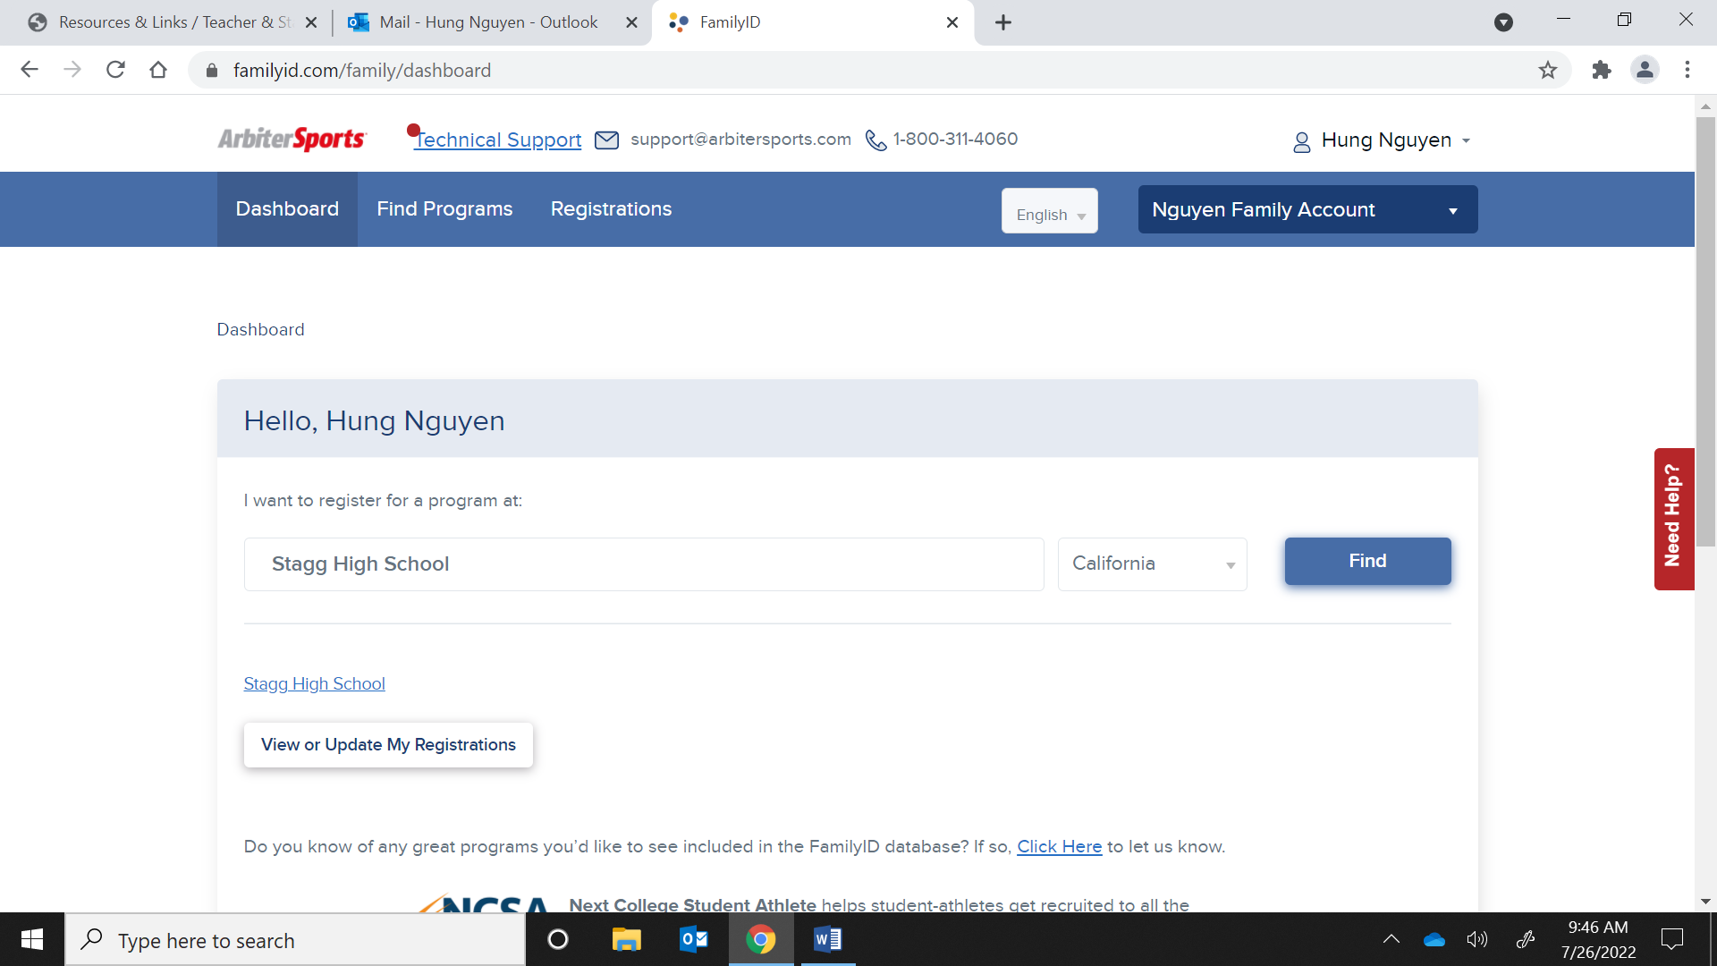

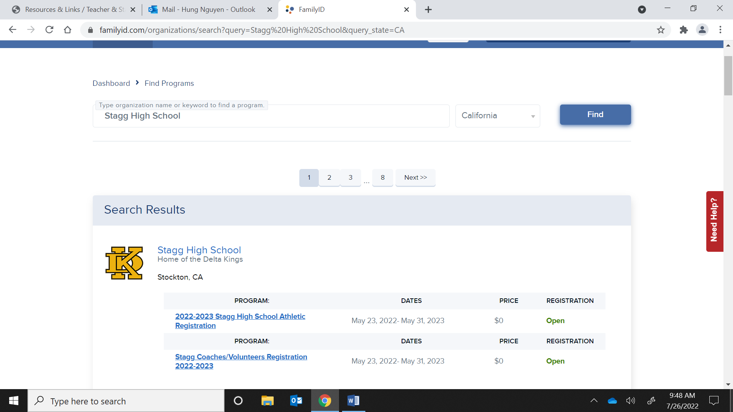

1. Click “Register Now”.
2. Check all the sports you want to play. Make sure to include the level (Varsity, JV, Frosh).
3. In the “Additional” section, make sure you add your most recent physical. You can take a picture of it on your phone.
4. Check the boxes and sign for the following agreements in the “Agreements” section:
   * Stockton Unified School District Signature Form
   * Consent for Medical Treatment
   * Informed Consent COVID-19

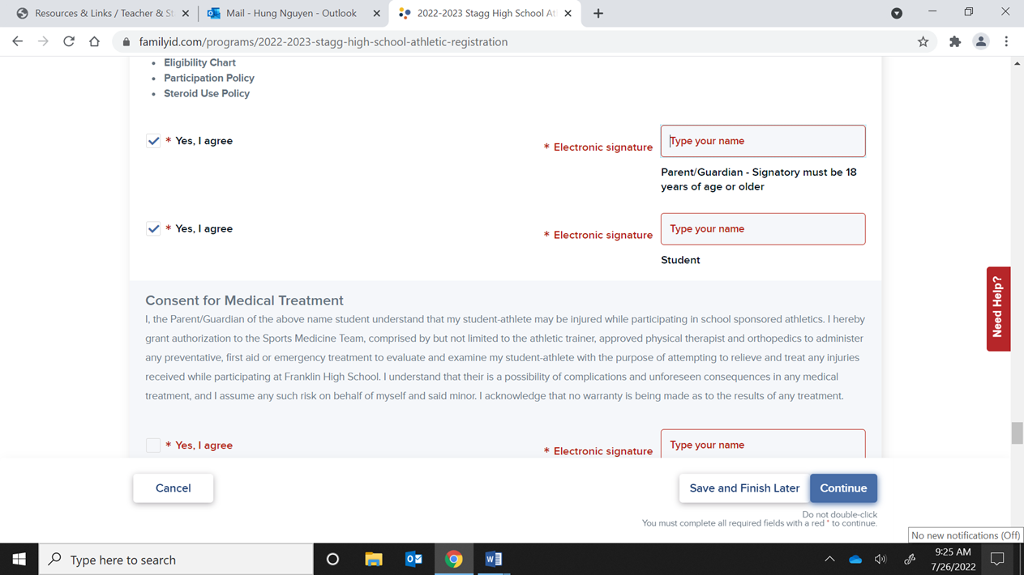

1. Make sure you’ve filled out everything with a red asterisk.
2. Click “Continue”.
3. Click “Submit”.

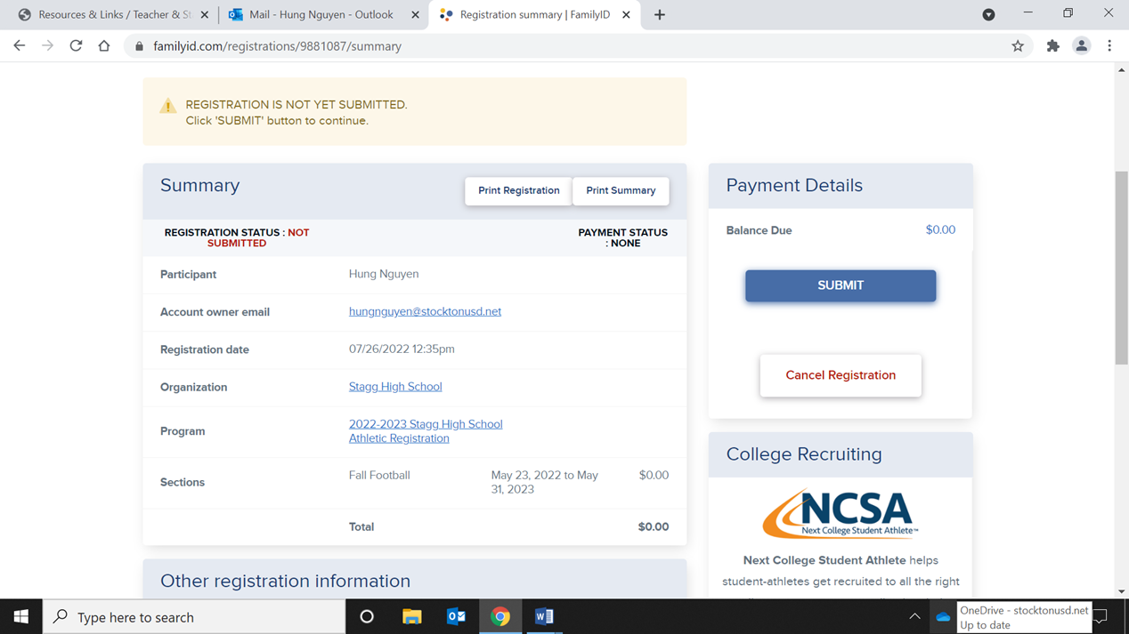

1. You will receive an email back within 24 hours (normally much quicker) with your approval, or the reason you were not approved.